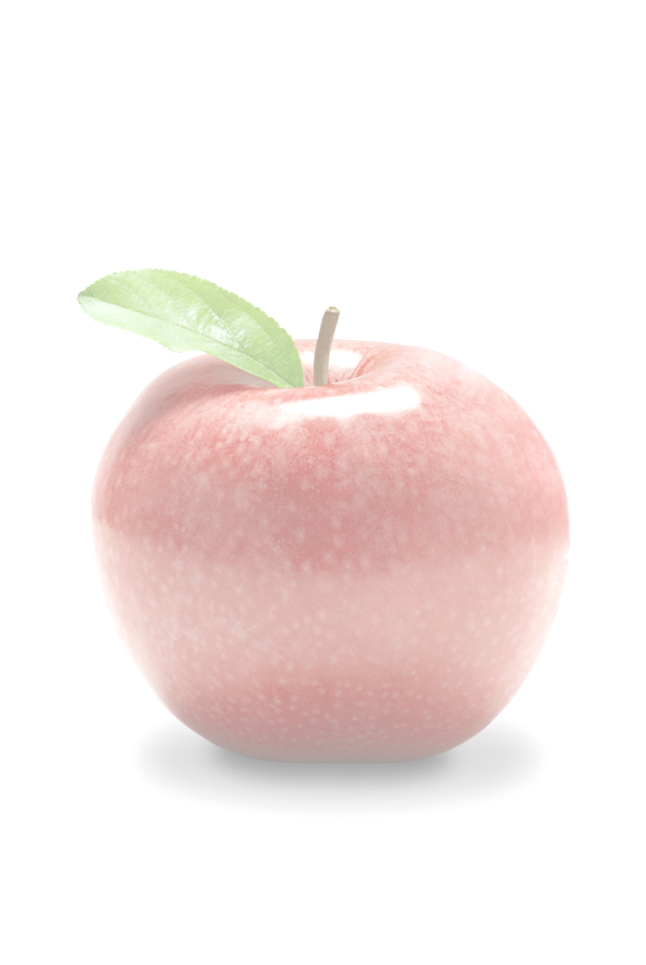
Ideas for Healthy Food Options at Work

The following suggestions can help you offer healthy foods and physical activity breaks to accommodate the needs of all your employees. By offering these healthy choices at workplace gatherings and events, you will be encouraging vitality and productivity while supporting workers’ interest in healthy eating and physical activity.

For Meals During Meetings For Snacks During Meetings Other Ways to Support Healthy Eating at Meetings
Include an abundance of fruits and vegetables to help keep attendees focused and full of energy.  - Serve cut-up fresh fruit for breakfast, as a salad, or for dessert.  - Serve salads with a variety of colorful vegetables and fruits.  - Offer delicious vegetable sandwiches or a sandwich tray with lots of fresh vegetables, sliced low-fat cheeses, lean meats, and low-fat spreads.  - Serve entrees and side dishes with tasty beans, peas, and lentils. | Serve delicious fruits and vegetables to keep attendees alert and productive.  - Bite-sized fruits and vegetables in-season like grapes, cherries, strawberries, baby carrots, cherry tomatoes, and broccoli florets.  - Whole, fresh fruits like apples, oranges, nectarines, plums, kiwifruit, and apricots.  - Cut-up fresh vegetables, like celery, squash, and bell peppers, served with low-fat or fat free dips.  - 100% fruit and vegetable juices, which are refreshing and nourishing alternatives to sugary drinks. | - Serve beverages, condiments, and other foods with little or no added sugar such as:  - Water  - 100% fruit and vegetable juices  - Regular and decaffeinated coffee or tea  - Vegetable spreads like hummus and pesto  - Serve fat free, low-fat, or low-calorie beverages, condiments, and other foods such as:  - Nonfat dairy products like nonfat milk and yogurt  - Low-fat or fat free salad dressings (served on the side)  - Low-fat dips, salsa, or mustard  - Whole grain crackers or air popped popcorn  - Lean meats, poultry, or fish that are served in small portions  - Low-fat or low-calorie desserts such as angel food cake or fruit sherbet  - Provide whole grain products like whole wheat or multi-grain breads, bagels, rolls and muffins, brown rice, or whole grain cereals.  - Serve foods low in sodium like unsalted pretzels, air popped popcorn, and entrees cooked with spices and herbs instead of salt.  - Offer smaller portions such as whole grain mini-muffins and mini-bagels.
Find recipes for delicious and healthy meals at www.fruitsandveggiesmorematters.org Upper Missouri District Health Unit 8/09

