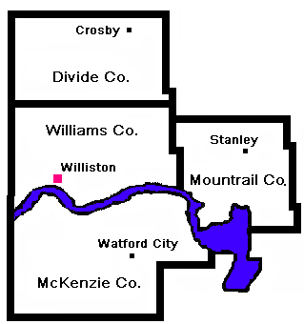

Upper Missouri District Health Unit

“Your Public Health Professionals”
DIVIDE COUNTY
Divide Co. Courthouse
P.O. Box 69
300 Main St. N
Crosby, ND 58730
Phone 701-965-6813
Fax 701-965-6814
MCKENZIE COUNTY
Northern Plains Building
P.O. Box 1066
109 W 5th St.
Watford City, ND 58854
Phone 701-444-3449
Fax 701-842-6985
MOUNTRAIL COUNTY
Memorial Building
P.O. Box 925
18 2nd Ave SE
Stanley, ND 58784
Phone 701-628-2951
Fax 701-628-1294

WILLIAMS COUNTY
110 W. Bdwy, Ste 101
Williston, ND 58801-6056
Phone 701-774-6400
Fax 701-577- 8536

Toll Free 1-877-572-3763

NEWS RELEASE

For Immediate Release: For More Information Contact:
July 21, 2017 Daphne Clark, Public Information Officer
701-774-6400

West Nile Disease Prevention

West Nile Disease is a virus spread by mosquitos. The number one way to prevent West Nile Disease is to prevent mosquito bites.

To reduce the risk of being bitten by mosquitoes, the Upper Missouri District Health Unit recommends the following protective measures:
- Use insect repellent containing DEET, picaridin, IR 3535, oil of lemon eucalyptus or permethrin when outdoors. Always follow the directions on the manufacture’s label.
- Limit outdoor activities between dusk and dawn when mosquitoes are most likely to bite.
- When possible, wear long pants and long-sleeved shirts while outside.
- Eliminate stagnant water and leaf debris in containers around homes where mosquitoes can lay their eggs (e.g., buckets, flowerpots, old tires, wading pools and birdbaths).
- Keep mosquitoes from entering your home by repairing screens in windows and doors.
- Keep the grass around your home trimmed.
- Clean roof gutters and downspout screens.

For more information see our website www.umdhu.org or contact Daphne Clark, Upper Missouri District Health Unit, 701-774-6400 or 1-877-572-3763.

-- 30 --

